Assignment 1
Name : Prathmesh Marathe
PRN : 123B1B186
Div : C

Assignment Title : Create a static web page which defines all text formatting tags of HTML in tabular format.

Objectives :
- To understand different HTML text formatting tags
- To learn how text can be styled and emphasized using HTML
- To represent information in a clear tabular format
- To design a basic static web page using HTML only

Outcomes :
After completing this assignment, the student will be able to:
- Identify various HTML text formatting tags
- Explain the purpose of each formatting tag
- Use formatting tags to enhance text appearance
- Create a simple static HTML webpage
- Present technical information in a structured table

Theory :
HTML (HyperText Markup Language) provides several text formatting tags that help improve the readability and presentation of content on a webpage.
These tags allow developers to:
- Make text bold, italic, or underlined
- Highlight important content
- Show inserted or deleted text
- Display superscript and subscript content
Text formatting tags are mainly used to:
- Emphasize important text
- Improve visual clarity
- Convey meaning to users
- Convey meaning to users

Program code with output screenshot :

<!DOCTYPE html>
<html lang="en">
<head>
<meta charset="UTF-8">
<meta name="viewport" content="width=device-width, initial-scale=1.0">
<title>HTML Text Formatting</title>

<style>
body {
background-color: #f4f6f8;
padding: 40px;
}

h1 {
text-align: center;
}

table {
border-collapse: collapse;
width: 70%;
margin: auto;
background-color: white;
}

th, td {
border: 1px solid #333;
padding: 12px;
text-align: center;
}

th {
background-color: #2c3e50;
color: white;
}

tr:nth-child(even) {
background-color: #f2f2f2;
}
</style>
</head>

<body>
<h1>HTML Text Formatting Tags</h1><br>

<table>
<tr>
<th>Tag</th>
<th>Description</th>
<th>Example Output</th>
</tr>

<tr>
<td>&lt;b&gt;</td>
<td>Bold Text (<a href="https://www.w3schools.com/tags/tag_b.asp">learn more</a>)</td>
<td><b>Bold</b></td>
</tr>

<tr>
<td>&lt;strong&gt;</td>
<td>Important Text (<a href="https://www.w3schools.com/tags/tag_strong.asp">learn more</a>)</td>
<td><strong>Strong</strong></td>
</tr>

<tr>
<td>&lt;i&gt;</td>
<td>Italic text (<a href="https://www.w3schools.com/tags/tag_i.asp">learn more</a>)</td>
<td><i>Italic</i></td>
</tr>

<tr>
<td>&lt;em&gt;</td>
<td>Emphasized text (<a href="https://www.w3schools.com/tags/tag_em.asp">learn more</a>)</td>
<td><em>Emphasized</em></td>
</tr>

<tr>
<td>&lt;u&gt;</td>
<td>Underlined Text (<a href="https://www.w3schools.com/tags/tag_u.asp">learn more</a>)</td>
<td><u>Underline</u></td>
</tr>

<tr>
<td>&lt;mark&gt;</td>
<td>Highlighted Text (<a href="https://www.w3schools.com/tags/tag_mark.asp">learn more</a>)</td>
<td><mark>Marked</mark></td>
</tr>

<tr>
<td>&lt;small&gt;</td>
<td>Smaller text (<a href="https://www.w3schools.com/tags/tag_small.asp">learn more</a>)</td>
<td><small>small</small></td>
</tr>

<tr>
<td>&lt;del&gt;</td>
<td>Deleted Text (<a href="https://www.w3schools.com/tags/tag_del.asp">learn more</a>)</td>
<td><del>Deleted</del></td>
</tr>

<tr>
<td>&lt;ins&gt;</td>
<td>Inserted Text (<a href="https://www.w3schools.com/tags/tag_ins.asp">learn more</a>)</td>
<td><ins>Inserted</ins></td>
</tr>

<tr>
<td>&lt;sub&gt;</td>
<td>Subscript Text (<a href="https://www.w3schools.com/tags/tag_sub.asp">learn more</a>)</td>
<td>H<sub>2</sub>O</td>
</tr>

<tr>
<td>&lt;sup&gt;</td>
<td>Superscript text (<a href="https://www.w3schools.com/tags/tag_sup.asp">learn more</a>)</td>
<td>x<sup>2</sup></td>
</tr>
</table>
</body>
</html>

Output :
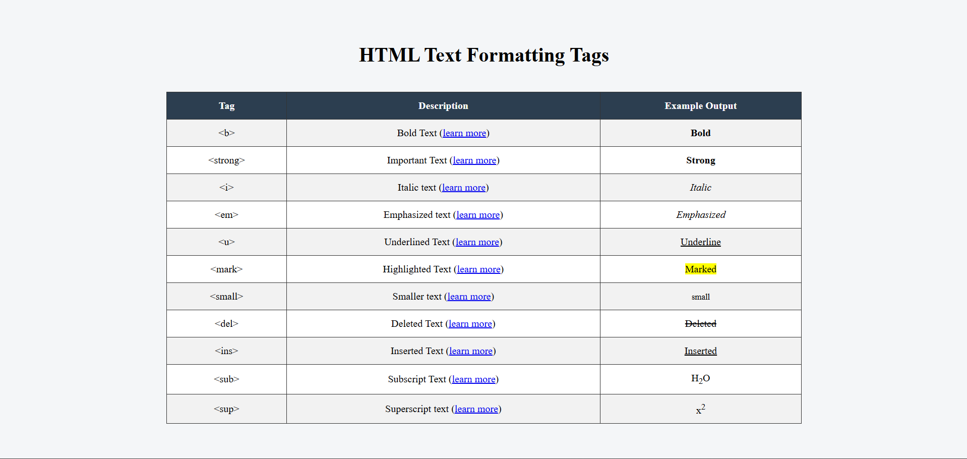

Conclusion :
In this assignment, we studied various HTML text formatting tags and their usage. By creating a static web page, we learned how these tags help in modifying the appearance of text such as making it bold, italic, underlined, highlighted, small, deleted, inserted, superscript, and subscript.
Presenting the information in a tabular format made it clear, organized, and easy to understand. This assignment strengthened our basic HTML concepts and helped us understand how text formatting enhances the readability and presentation of web pages.

